Lesson plan: Mayan long count (inspired by the Cyber coding curriculum thread)
Spanish 3/4 (Second year Spanish)
Kendra Wisely

Objective: Students will learn the history of their own number system and learn to read ancient numerical hieroglyphs of the Mayan culture.

Purpose: To expose students to cultural differences that exist in Mayan numerology/Long count system (base 20) vs. The Hindu-arabic numerals system (base 10). Students will also learn about the cultural differences between an absolute time scale and a Gregorian (repeating) calendar system.

Timeframe: One 90 min. block period

Materials: 1 computer/student (to access Smithsonian.com)

Anticipatory Set: (In Spanish) What’s the date today? How do you know? What is our time-keeping system?
Discuss: Calendar, month/day/year notation vs. day/month/year
Discuss: Gregorian calendar (repeating) vs. absolute timescale (based on a creation date and time was measured forward)

Lesson:

- Show Mayan real life examples of Long count dating with Powerpoint visuals:
Many inscriptions are found in the Mayan towns which give the date of erection in terms of this long count.

Example 1: [ 8;14;3;1;12 ] is the date given on a plate which came from the town of Tikal. It translates to 12 + 1 × 20 + 3 × 18 × 20 + 14 × 18 × 20² + 8 × 18 × 20³ which is 1253912 days from the creation date of 12 August 3113 BC so the plate was carved in 320 AD.

Example 2: [ 9;8;9;13;0 ] is the completion date on a building in Palenque in Tabasco, near the landing site of Cortés. It translates to 0 + 13 × 20 + 9 × 18 × 20 + 8 × 18 × 20² + 9 × 18 × 20³ which is 1357100 days from the creation date of 12 August 3113 BC so the building was completed in 603 AD.

Application: students calculate today’s date and their birthday

2. Introduce formal dating system based on drawings/characters, used for dating buildings, used on calendars etc.:
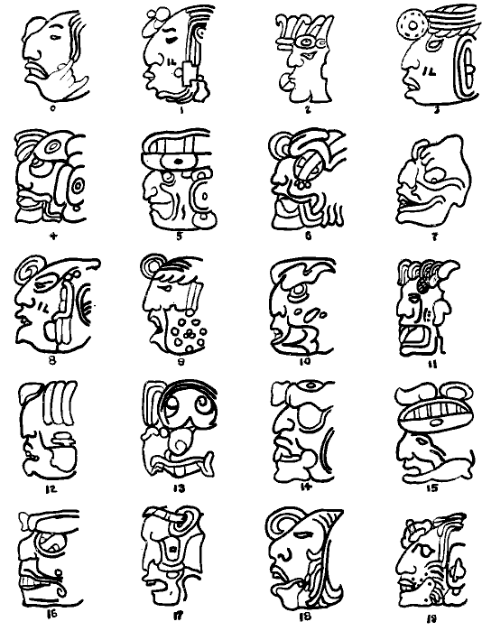

3. Introduce Mayan Long Count calendar background using prepared PowerPoint

- Mayan civilization began 1000 BC
- Classic period: AD 260 - 900 = flourish of civilization
- 12 August 3113 BC (not all historians agree that this was the zero of this so-called "Long Count")
- The Long Count is based on a year of 360 days

Cultural comparison guiding questions: Why do we use base 10? (10 digits) Mayans used 5 and 20 as base - where did these numbers come from?

Introduce numerology symbols w/ visual aid:
- Ancient maya civilization, place value system, zero (shell) as placeholder - first to develop place value system & symbol for zero
- Shells, pebbles, and sticks (original counting manipulatives)
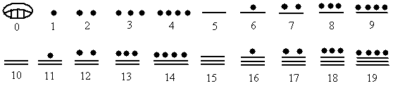

- Explain that the Mayan system counts vertically rather than horizontally
- Practice pronunciation in language of origin (K’iché Mayan) and discuss meaning (each number is written in English, Spanish, K’iché Mayan with pronunciation):
One, Uno, Jun (pronounced Yoon) Source, Beginning, Unity, Firm, Resolute, Oneness, Whole
Two, Dos, Keb’ (pronounced Kabe) Polarity, Duality, Balance, Choices, Understanding
Three: Tres: Oxib’ (Osh’ eeb) Rhythm, Movement, Action, Integrate, Trinity
Four, Cuatro, Kajib’ ( Kah’ heeb) Stability, Complete, Cube, Order, Measure
Five, Cinco, Job’ ( Hobe) Empower, Center of the Cube, Fingers and Toes
Six, Seis, Waqib’ ( Wah’keeb) Flow, Time/Space, Ultimate stability
Seven, Siete, Wuqub’ ( Woo’koob) Reflective, See both backwards and forwards
Eight, Ocho, Wajxaqib’ (Wash’a keeb) Balance, Justice, Harmony
Nine, Nuevo, B’elejeb’ (Bay’ lay heeb) Great Cycles, Patience, Life Number
Ten, Dias, Lajuj (Lah’ hooh) Manifestation, Complete, Cooperation
Eleven, Once, Ju’lajuj (Yoo’lah hoo) Dissonance, Resolution, Power
Twelve, Doce, Kab’lajuj (Kob’ lah hoo) Understanding, Accumulation, Totality
Thirteen, Trece, Oxlajuj (Osh’ lah hoo) Completion, Ascension
- Play video of mayan ritual involving numbers; have students practice counting along https://www.youtube.com/watch?v=Ybvb7oy_WV0

- Compare to familiar number systems:
  - Hindu-arabic numerals (India → Africa) = 0,1, 2, 3, etc.
  - Roman Numerals (M, D, C, L, X, V, etc.)
Independent Practice: Studets will use individual chromebooks to access the Smithsonian Living Maya Time website at https://maya.nmai.si.edu/maya-sun/maya-math-game?game=practice-2
Round 1: practice math using mayan numerals 0-19
Round 2: practice conversion into mayan numerals with familiar base 10 system
Round 3: practice conversion into mayan numerals with mayan base 20 system
Round 4: practice addition using mayan numerals/base 20 system
Round 5: practice subtraction using mayan numerals/base 20 system

Further cultural application: At the end of each round, students “unlock” the name of a Mayan God for whom they are trying to guess the name of throughout the entire round by completing the math and reading specific clues about their role in Mayan astrology. In this way, students are not only practicing base 20 conversion and and working in a vertical number system, but they are learning the cultural history from where it comes.

Evaluation/Closure: Students will be asked to report in written form the level that they reached as well as a short summary about one of the Gods that they learned about while practicing.

