DRAFT #1
Introducing Quantum Cryptography as an Application to Modern Physics

This lesson is designed to be used as an example of an application of modern physics concepts. The goal of the lesson is to give context for the value of modern physics as it applies to the necessity of secure communications. The following conceptual understandings are assumed:

-Circuits-
-Wave motion- principle of polarization, cancelation and superposition
-Wave particle duality-
-Heisenberg’s uncertainty principle-
-Mass energy equivalence-
-Radioactivity- Specifically the creation of parent and daughter particles.

Materials:
Coins so long as they are all the same.
Create paper cut outs to show the polarization filter and detection filter.

Day 1-

Introduce the ideas of security and privacy with the students in a discussion format (Socratic seminar or philosophical chairs). The end result of the discussion should be that the students have a cumulative understanding for the importance of privacy and thus the importance of security. This will provide context for driving the importance developing more secure systems.

Some discussion questions the teacher should consider:

-What should be considered private?
-On what basis do you feel a government has the authority to access your information?
-What information do you think is valuable?
-What systems are at risk if they are not secure?

Homework: Have students watch John Oliver’s Edward Snowden Interview

Day2-

Continue the discussion (for the first half of class) from day one. Ask the students some of the following questions:

-How did what you watched last night relate to our conversation yesterday?
-What did you learn? Did your opinion of privacy and security change at all?

This is where a connection to physics and science should be made.
-How do these idea connect to your scientific education?
-How could we use the rules of nature to help us secure communications?

Introduce the following slide/information:
(Author’s Note: I am very unsure as the best way to do this…)

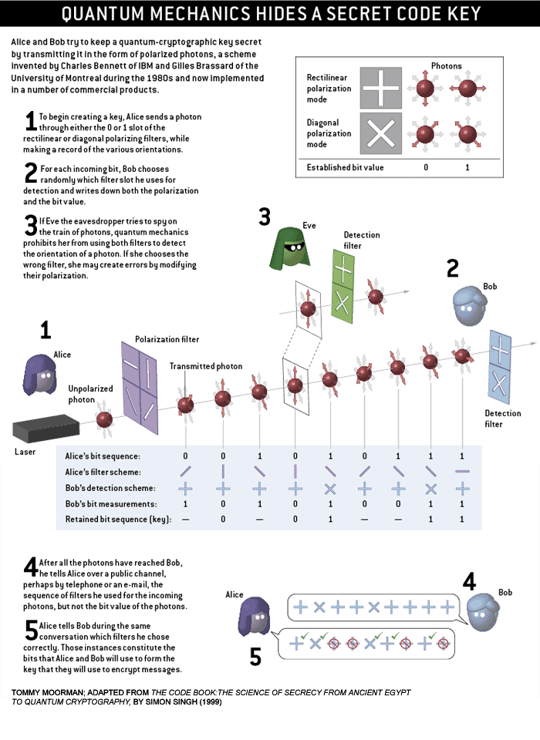
Day2/3 (depending on the quality and length of the day 2 discussion)-
(Authors Note: this is very basic and I feel that it lacks some key details, however, I feel it gets the broad concept across.)

Activity- Have students line up across the classroom. Choose one student to Alice and another to be Bob. The rest of the student will be considered the medium through which the information will be transmitted. Tell the students they are part of a quantum system in which the measurement changes the observation. Show them that a coin (a quarter in this example) can have 4 different orientations and 2 different quantum states:

Heads OR Tails OR Heads or Tails

OR

This will mimic the polarization of quanta (either light or particles). Tell the students whom represent the medium that if they see (ie measure) any quarter they must change its quantum state (meaning they have to change the quarter from head to tails or tails to heads).

Instruct the students that they will have to pay attention to how they receive the coins. (But that they have to try to no look at them.)

Have the students who represent Bob and Alice get together and determine a sequence of 5-10 coins. (Remember that if Bob makes a measurement he will see a different quantum state as well, so remind the students that Bob should know what the sequence should be for when he takes his “measurement”.)

Have Alice pass the coins down the medium in their predetermined order using the filters to show how they are polarized. The class will need to look at this to understand it so the first few times through you should allow the whole class to look at the coins without them changing the quantum state (head to tails or tails to heads) so that they all can try to make a connection with the physical model. Hopefully they realize that if Bob receives the predetermined sequence of measurements that they have a secure system.

Now introduce Eve (a hacker). Pick one student from the medium and ask them to start looking at the coins. Because Eve looks at the coin he/she will change the quantum state and the result will be that Bob’s measurements will be wrong and thus Bob and Alice will know they have a compromised communication system (thus they can terminate the connection).

Reflection-
Have students reflect on the experience ask some leading questions that integrate knowledge of physics and engineering.

-Should this idea become standard for all data that exists on the Internet?
-What kind of infrastructure to do feel would need to be developed to support secure communications?
-Who should be responsible for the technology? Both development and sustainability.

Authors Note: I am seeking help with the development of this lesson. Constructive criticism/commentary is always welcome. It is very much a FIRST draft.

